**Project Report – 1**

**On**

**Stock Market Prediction System**

**Subject Code: 3IT31**

**Subject: Mini Project**

**Academic Year: 2023 – 2024**

**Team Members: Pratham Satani (21IT417)**

**Vatsal Patel (21IT414)**

**Deep Hirapara (21IT403)**

**Batch: D – 10**

**Project Guide: Dr. Z. H. Shah**



**Birla Vishvakarma Mahavidyalaya**

**Engineering College, Vallabh Vidyanagar**

**[An Autonomous Institution]**

**Table of Contents**

Definition 3

Objective 3

Primary Objective 3

Secondary Objective 3

Scope 4

Technical Scope 4

Functional Scope 4

Modules 4

Data Acquisition and Management 4

Sentiment Analysis 4

News Feed 4

User Interface 5

Prediction module 5

Basic Requirements 5

Hardware Requirements 5

Software Requirements 5

Literature Review 6

Feasibility Study 7

Technical Feasibility 7

Economic Feasibility 7

Legal and Regulatory Feasibility 7

Requirement Gathering 7

Timeline Chart 8

Work Distribution 9

UML Diagrams 9

Use Case Diagram 9

Dataflow Diagram 10

Activity Diagram 12

Class Diagram 13

References 14

Project Implementation 15

1. **Definition**

The Stock Market Prediction System is a bold venture into the realm of financial forecasting, aiming to unveil the enigmatic tapestry of the market and empower investors with actionable insights. It transcends the limitations of mere prediction, serving as a comprehensive analytical platform that equips users to navigate the ever-shifting landscape of financial landscapes.

1. **Objective**

2.1. Primary Objective:

1. To accurately predict short-term (next two months) price movements for a diverse range of listed companies, empowering investors to make informed trading decisions and maximize returns.

2.2. Secondary Objectives:

1. Technical Analysis:
   * Develop a user-friendly interface for interacting with various technical charts and indicators, catering to both novice and experienced users.
   * Enable users to customize charts and indicators according to their individual preferences and strategies.
   * Integrate company-specific data onto charts for comprehensive contextual analysis.
2. ML-powered Prediction:
   * Train and maintain machine learning models that utilize historical data and real-time market factors to generate accurate and reliable price forecasts.
   * Provide probability distributions and confidence levels for predictions to allow users to assess potential risk and reward.
   * Offer scenario planning based on external events and their predicted impact on market behaviour.
3. Market Sentiment Analysis:
   * Implement natural language processing and sentiment analysis techniques to gauge investor sentiment towards individual companies, sectors, and the overall market.
   * Track sentiment trends over time to identify potential turning points and shifts in market psychology.
   * Deliver actionable insights based on sentiment analysis to inform investment decisions.
4. **Scope**

3.1. Technical Scope:

* Data: The system will initially focus on readily available financial data sources like historical price charts, financial ratios, and news articles. Integration with live market data feeds can be considered in later phases.
* Prediction Models: The system will focus on one of the few well-established Machine Learning models for price prediction, like LSTM. More advanced models can be included later based on performance evaluation.
* Platform: The system will be developed as a web application accessible through standard web browsers, with potential for mobile app development in later stages.

3.2. Functional Scope:

* Prediction: The system will focus on predicting price movements for the next two months with various confidence levels. Offering predictions for longer timeframes can be considered later.
* Analysis: The system will primarily focus on technical analysis and market sentiment analysis.

1. **Modules**
   1. . Data Acquisition and Management:
   * Gathers historical price data, financial ratios, news articles, and social media sentiment from reliable sources.
   * Cleanses, preprocesses, and stores data in appropriate formats for analysis and model training.
   * Implements data quality checks and safeguards to ensure integrity and accuracy.
   1. . Sentiment Analysis Module:
   * Analyses news articles, social media posts, and forum discussions to gauge sentiment towards stocks and sectors.
   * Identifies nuanced emotions like confidence, fear, and anticipation using natural language processing.
   * Tracks sentiment trends over time to identify potential turning points and shifts in market psychology.
   1. . News Feed Module:
   * Aggregates financial news from reliable sources and filters based on user interests and watchlists.
   * Summarizes key articles and highlights relevant information using machine learning.
   * Provides real-time alerts for breaking news and significant sentiment shifts.
   1. . User Interface Module:
   * Implements a user-friendly and intuitive web interface accessible through standard browsers.
   * Provides clear navigation, informative visualizations, and interactive elements for seamless user experience.
   * Supports personalization of charts, predictions, and news feeds based on user preferences.
   1. Price Prediction Module:

* Applies various ML techniques like LSTM prediction to predict future closing prices.
* Provides with predictions for up to next two months’ time frame.
* Identifies zones of interest like High Volatility, High Volume etc.

1. **Basic** **Requirements**
   1. . Hardware Requirements
   * Server-side:

* Processor: Intel Xeon or better with multiple cores.
* RAM: 16 GB or more depending data volume and usage.
* Storage: SSD for better retrieval of data.
* Network: High speed internet for low latency.
* Client-side:
* Mobile phone with 32/64-bit ARM processor with active internet connection.
* Desktop computer or laptop with active internet connection.
  1. . Software Requirements
* Server-side:
* OS: Windows or Linux
* Client-side:
* All devices should have a JavaScript enabled web browser.
* RAM: 8 GB or more.

1. **Literature Review**
2. This paper proposes a hybrid model combining Convolutional Neural Networks (CNNs) and Bi-directional Long Short-Term Memory (BiLSTM) networks for stock closing price prediction. The CNNs extract spatial features from historical price data, while BiLSTMs capture temporal dependencies. Their model demonstrated superior performance compared to traditional methods like ARIMA and achieved promising accuracy in predicting next-day closing prices.
3. This project utilized Gated Recurrent Units (GRUs), another type of recurrent neural network, for daily stock closing price prediction. The study emphasizes the importance of data cleaning and feature engineering in improving model performance. The GRU model achieved competitive accuracy while highlighting the potential of deep learning approaches in this domain.
4. This paper employed LSTM networks to analyse and predict stock market trends. LSTMs excel at handling sequential data like historical prices, allowing the model to learn long-term dependencies. The study showcases the visualization of predictions alongside actual prices, offering valuable insights into market behaviour.
5. This blog post provides a practical overview of various machine learning methods for stock price prediction. It compares the performance of techniques like Simple Moving Average (SMA), ARIMA, and Random Forests, highlighting their strengths and limitations. This resource proves valuable for beginners seeking an accessible introduction to the field.
6. This research investigated the effectiveness of Artificial Neural Networks (ANNs) and Random Forests in predicting closing prices for diverse companies. The study emphasizes the impact of incorporating technical indicators like Moving Average Convergence Divergence (MACD) as model features. The findings support the efficacy of machine learning techniques in stock price prediction while urging further research on optimizing model parameters.
7. **Feasibility Study**
   1. . Technical Feasibility

Recent advancements in machine learning and AI offer promising tools for analysing vast amounts of financial data and identifying patterns. Techniques like deep learning, natural language processing, and sentiment analysis can potentially capture complex relationships and extract valuable insights from various sources, including:

* Historical stock prices
* Financial news and reports
* Economic indicators
* News sentiment
  1. . Economic Feasibility

Developing and maintaining a sophisticated prediction system requires significant resources for data acquisition, infrastructure, and expertise. The potential benefits depend on the system's accuracy, reliability, and the targeted user base. Monetization strategies could include subscription fees, trading signals, or partnerships with financial institutions. A thorough cost-benefit analysis is crucial to assess the project's financial viability.

* 1. . Legal and Regulatory Feasibility

Financial regulations and investor protection laws need to be carefully considered. The system should be transparent, avoid misleading claims, and comply with relevant data privacy regulations. Legal counsel is essential to ensure adherence to all applicable legal and regulatory requirements.

1. **Requirement Gathering**

8.1. Techniques

* Interviews:

Conduct interviews with financial analysts, traders, and potential users to understand their needs and expectations from a stock market prediction system.

Gather insights into the specific features, data sources, and analytical tools they find valuable.

* Surveys:

Create surveys to collect quantitative data from a broader audience, including investors and market enthusiasts.

Use surveys to identify common preferences, desired functionalities, and challenges faced by users in making investment decisions.

* Prototyping:

Develop prototype models of the stock market prediction system to gather early feedback from potential users.

Iteratively refine the prototypes based on user suggestions and preferences.

* Focus Groups:

Organize focus group discussions with diverse participants to explore different perspectives on stock market prediction needs.

Encourage participants to share their experiences and preferences regarding similar tools.

* Domain Experts Collaboration:

Collaborate with finance and machine learning experts to understand the intricacies of stock market analysis.

Leverage their domain knowledge to identify critical requirements and features necessary for accurate predictions.

8.2. Comparison of existing applications

As of today, there are no such official applications available that accomplish the task of predicting price of a listed company purely on the basis of historical data. This comparison of this application with other existing applications is not possible.

1. **Timeline Chart**

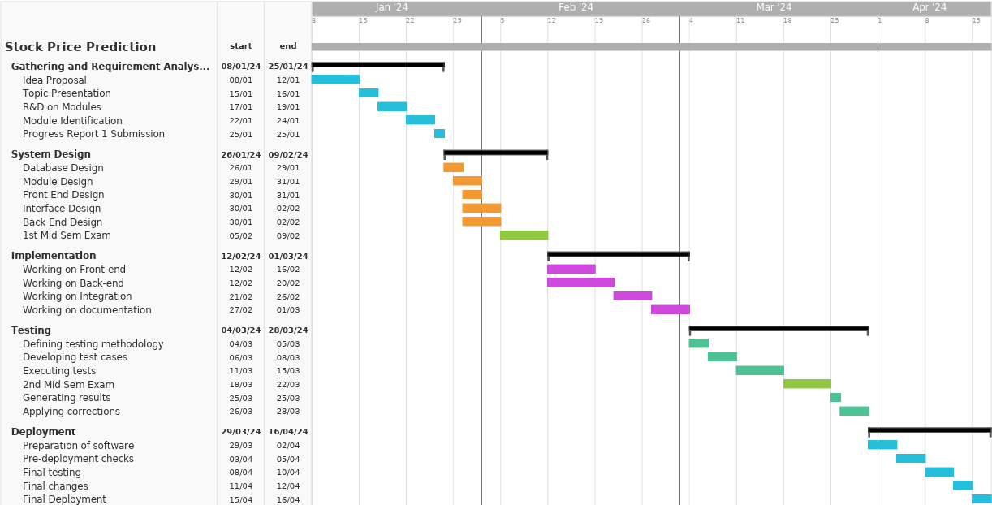

**Fig. 1: Timeline Chart**

1. **Work Distribution**

* Front-end development: Vatsal Patel (21IT414)
* Development of web page templates using HTML, CSS, JS, etc. and various other frameworks.
* Back-end development: Pratham Satani (21IT417)
* Development of ML models, their training, testing etc.
* Applying various data preprocessing techniques.
* Integrating Front-end with Back-end: Deep Hirapara (21IT403)
* Connecting front-end and back-end with Django.
* Setting up relevant data transfer methods for efficiency.

**11. UML Diagrams**

11.1. Use Case Diagram

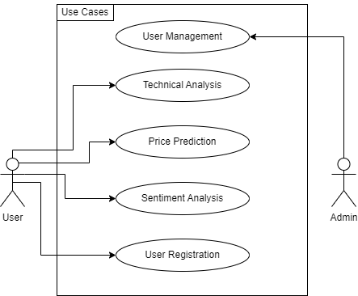

**Fig. 2: Use Case Diagram**

11.2. Data-Flow Diagrams

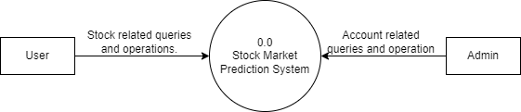

**Fig. 3.1: DFD Level 0**

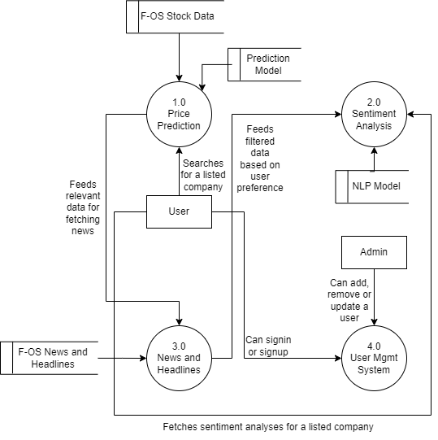

**Fig. 3.2: DFD Level 1**

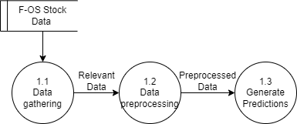

**Fig. 3.3: DFD Level 2 – Price Prediction**

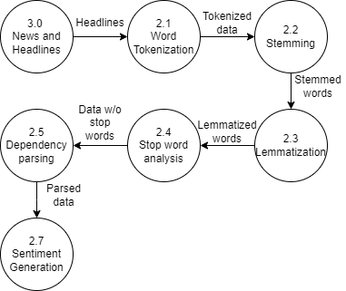

**Fig 3.4: DFD Level 2 – Sentiment Analysis**

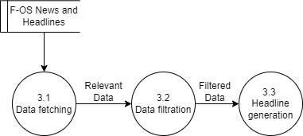

**Fig. 3.5: DFD Level 2 – News and Headlines**

11.3. Activity Diagram

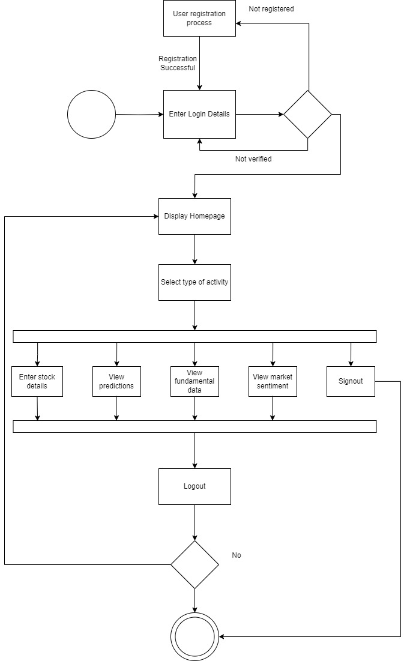

**Fig. 4: Activity Diagram**

11.4. Class Diagram

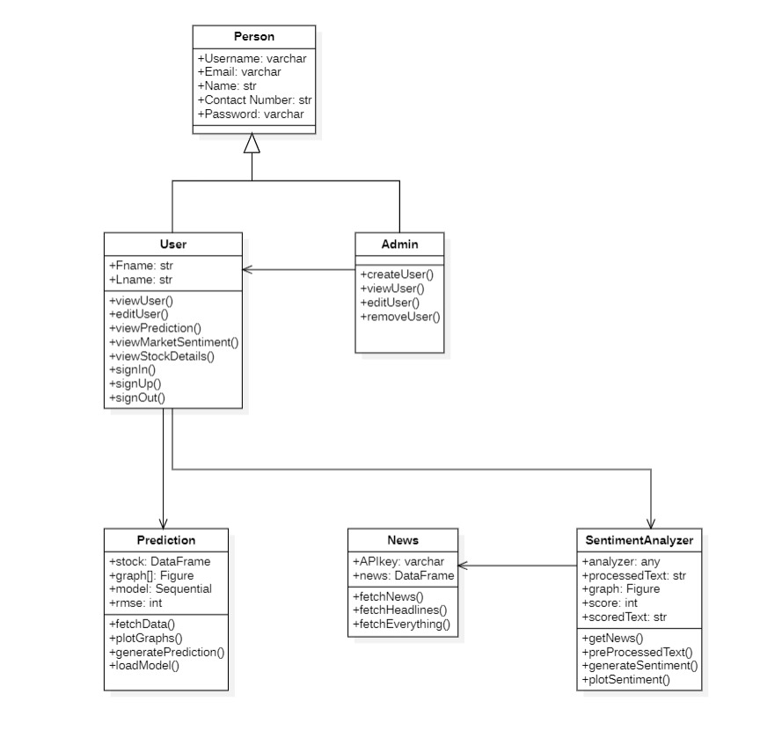**12.** **References:**

1. H. Wang et. al., “A Stock Closing Price Prediction Model Based on CNN-BiSLSTM”, Complexity, Vol. 2021, 2021.
2. Cloudxlab, “Stock Closing Price Prediction using Deep Learning, TensorFlow2 & Keras”, 2023.
3. F. Sayeh, “Stock Market Analysis + Prediction using LSTM”, Kaggle, 2021.
4. K. Li, “Predicting Stock Prices Using Machine Learning”, Neptune.ai, Blog, 2023.
5. M. Vijh et al. “Stock Closing Price Prediction using Machine Learning Techniques”, Procedia Computer Science, Vol. 167, Pages 599-606, 2020.

**Remarks/ Suggestions:**

**Signature:**

**13. Project Implementation (up to 30%)**

13.1. Index Page

This is the page where user first lands whenever he/she opens the site. This page provides the general overview. User needs to log-in/sign-up for using the tools.

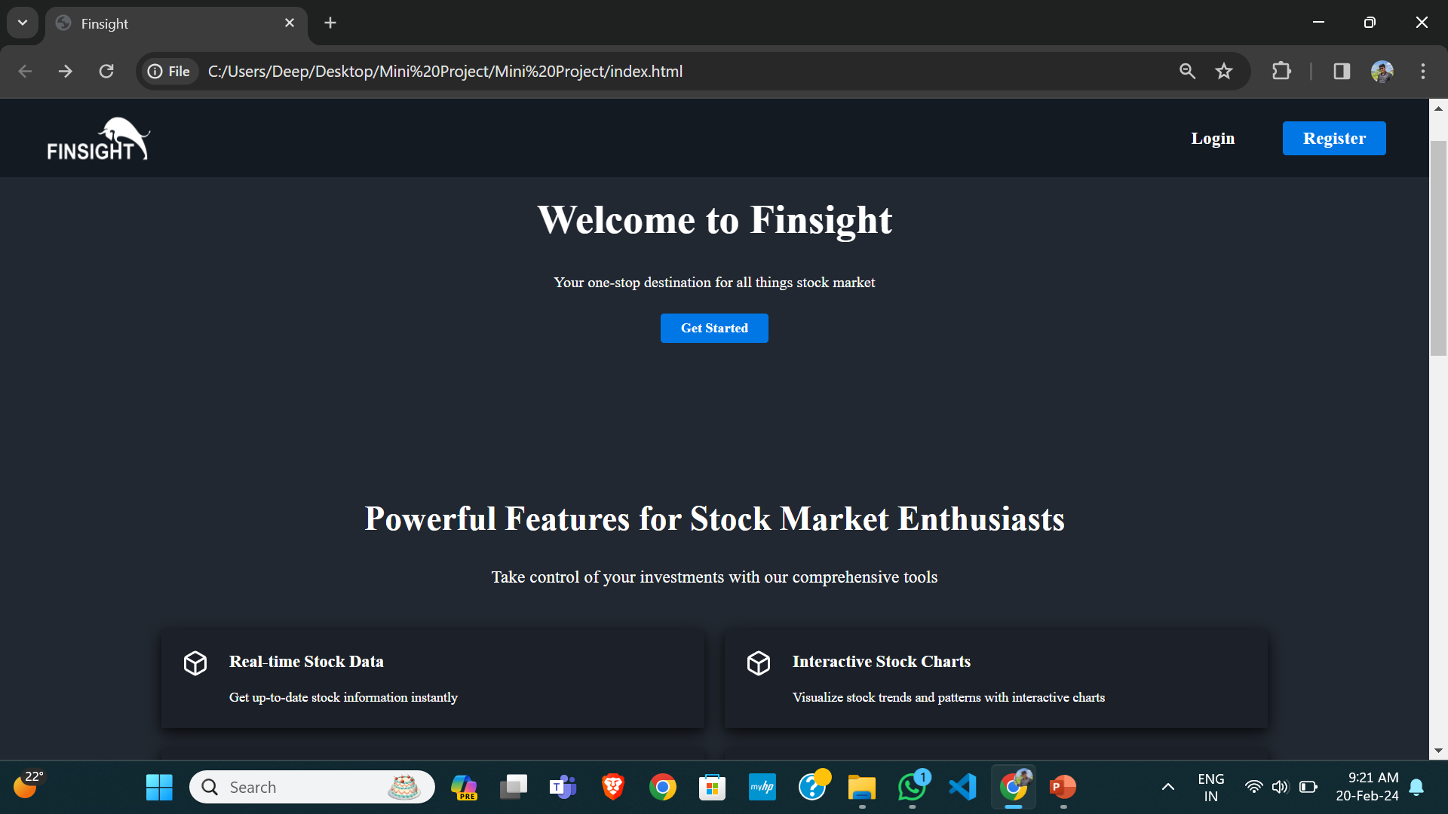

**Fig. 13.1: Index Page**

13.2. Home Page

This page provides users with general overview of the current market. It contains various indices and stocks of Indian market.

It also contains the graph of any particular stock along with the financial of that particular company.

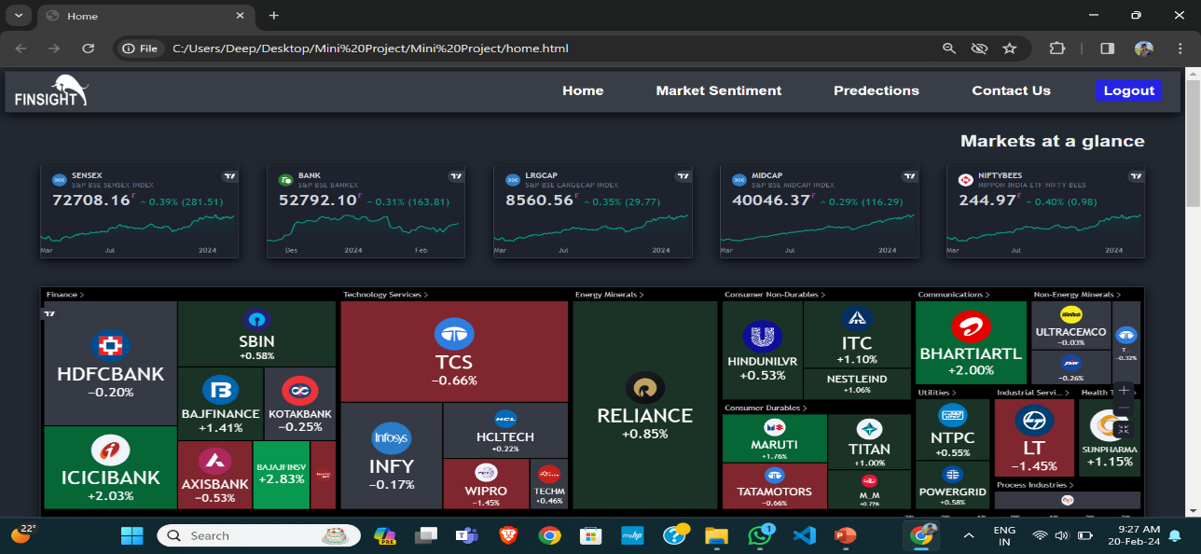

**Fig. 13.2: Home Page**

13.3. Predictions Page

A prediction page contains the moving averages, SMA and the prediction of the share price up to next two months.

These predictions are made on the basis of historical data and movements in the stock price.

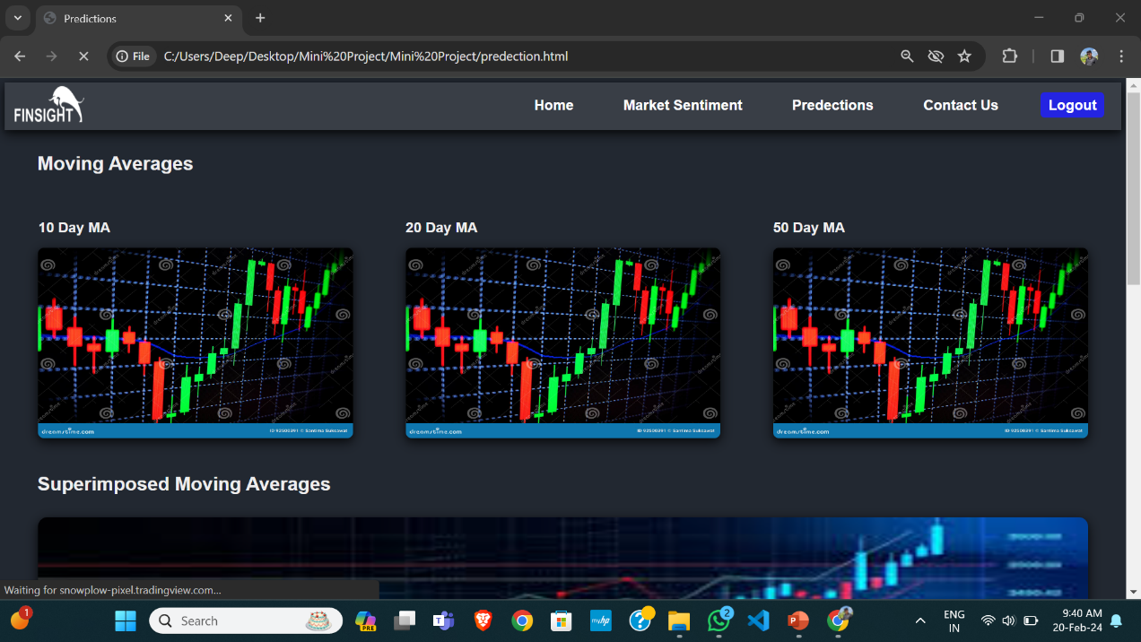

**Fig 13.3.1: Predictions Page**

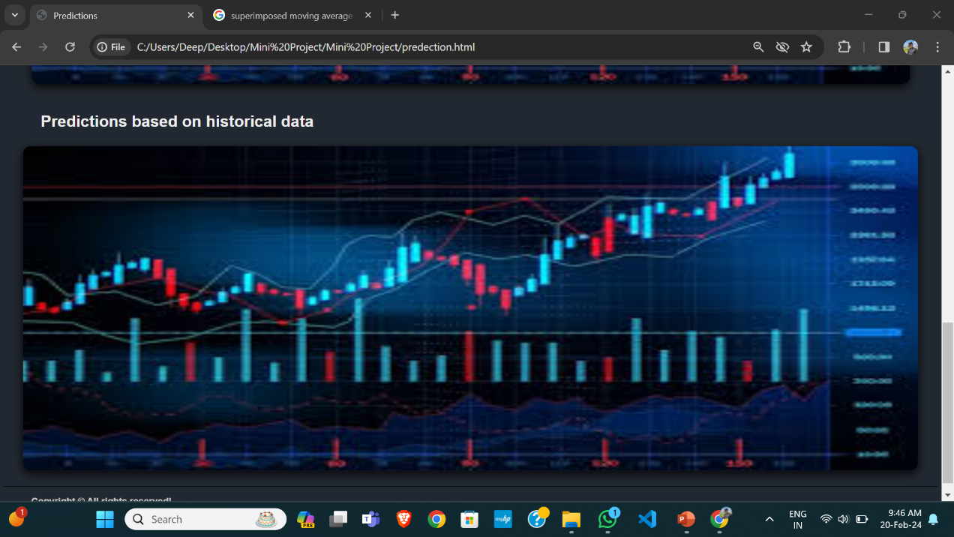

**Fig 13.3.2: Predictions Page**

13.4. Market Sentiment Page

This page provides the information about the overall mood of the brokers and investors about a stock or the stock market as whole.

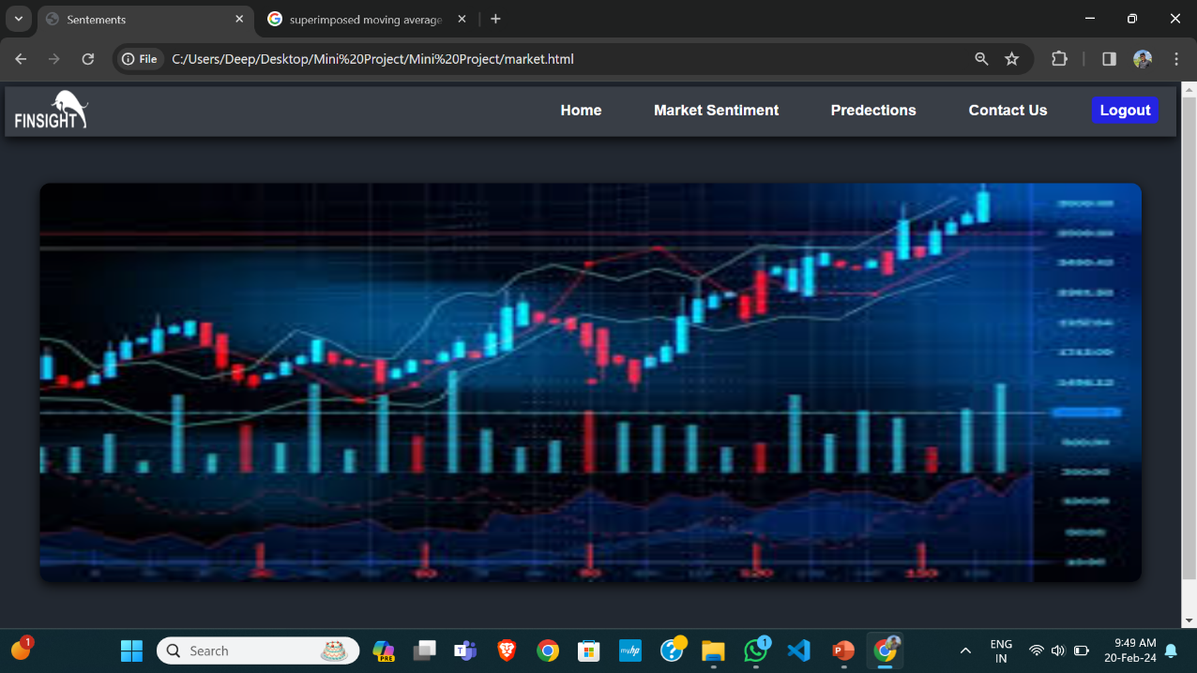

**Fig 13.4: Market Sentiment Page**

13.5. Contact Us Page

This page allows the users to interact with the admin for asking their doubts, for any suggestions regarding the predictions or for any complain due to improper functioning of the tools.

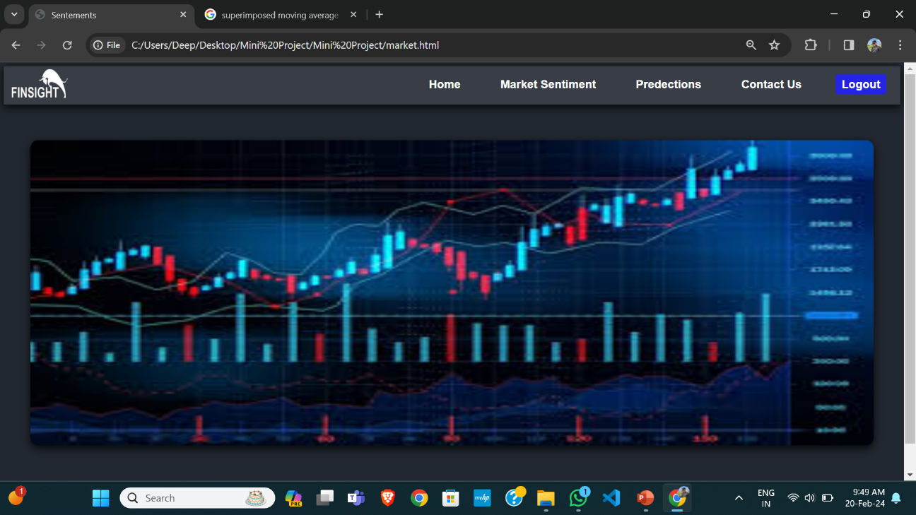

**Fig. 13.5: Contact Us Page**

13.6. Sign in Page

A sign-in page is that allows users to log into their existing account on a website. The page typically includes a form that prompts users to enter their login credentials, such as their email address and password.

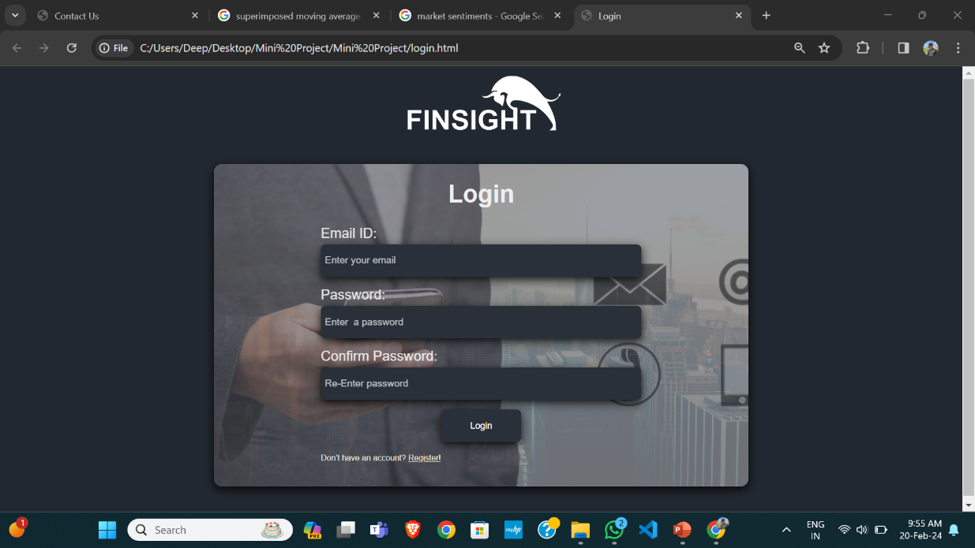

**Fig. 13.6: Sign In Page**

13.7. Sign up Page

A sign-up page is that allows users to create a new account on a website. The page typically includes a form that prompts users to enter their personal information, such as their name, email address, and password.

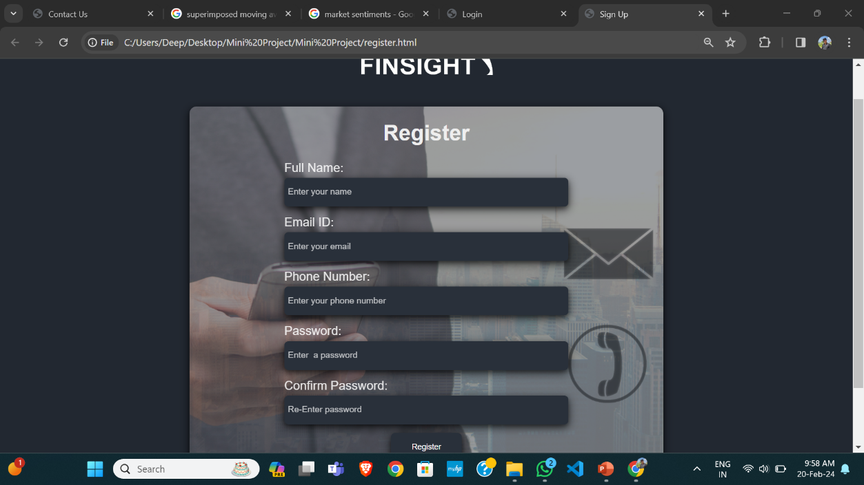

**Fig. 13.7: Sign Up Page**

**Remarks/Suggestions:**

**Signature:**